Persuasive Speech Final Draft

To Ease Both You and Me

- General Purpose: To persuade

- Specific Purpose: To persuade my audience to begin incorporating anxiety and stress management skills into their daily routine.

- Central Idea/Thesis Sentence: Integrating anxiety and stress reducing practices into one’s lifestyle will improve individual physical and mental wellbeing.

- Introduction (Attention): To start this off, I think it’s safe to assume that everyone, if not most of us have felt anxious about something – or even stressed out. Especially during the COVID-19 pandemic, I’m sure majority of us have felt anxious about moving forward after being isolated from others for so long. In 2021, the American Psychiatric Association conducted a survey on 1000+ adults and it found that 62% of people were more anxious in 2020 than the previous year. To combat the increasing amount of people affected by anxiety and stress, we can make an effort to better ourselves by integrating management skills, such as daily movement and eating stress-reducing foods. By committing to these anxiety and stress reducing habits, we can improve both our physical and mental health. Being abnormally anxious myself, I found that these habits have really helped in decreasing my already high stress levels.

[It’s common knowledge that anxiety and stress is a negative emotion, but it’s not so common about how it happens.]

- Need (Problem): The public, including adolescents are in dire need of anxiety and stress management skills.

- In recent years, teenagers and adults – mainly women are prone to high stress levels and anxiety disorders.
- To see the risks anxiety and stress presents on individuals, we must first understand what it really means to be anxious and/or stressed.
- Lisa Drayer, a health & nutrition contributor for CNN, explains that chronic stress poses significant health risks, mainly causing an excess in inflammation.
- High levels of cortisol, a hormone that treats inflammation, is regularly found with elevated blood sugar levels, weight gain, hypertension according to Philadelphia-based dietician Felicia Porrazza.
- Symptoms like anxiety and depression have skyrocketed in adolescents, following COVID-19.
- A 2022 CQ Researcher article written by Barbara Mantel stated, “researchers blame the growing use of social media, increasing academic pressure, shortages in mental health care providers” for the decrease in youth mental health.
- Furthermore, Mantel wrote that, “the COVID-19 pandemic intensified the crisis,” since children missed being with friends and having outside activities.
- Women are far more likely to experience anxious and stressed-out emotions than men.
- A 2006 Gale article written by Susan Mahler stated that women are 2-3 times more likely to develop an anxiety disorder than men.
- To add on, Mahler wrote, “women with a history of childhood physical or sexual abuse are at a higher risk of depression and/or anxiety.”
- Mahler added that women are 2x more likely to have Generalized Anxiety Disorder (GAD), which is severe anxiety that constantly interferes with daily activities.

[To combat these statistics, adults and teens can turn to anxiety and stress reducing skills.]

- Satisfaction (Solution): Encourage the incorporation of anxiety and stress reducing habits and how to begin implementing them.

- Creating habits with the purpose of bettering your health is vital to reducing your anxiety and stress levels.
  - Starting with easy tasks can help you get started.
- NYC-based endocrinologist Dr. Caroline Messer explained that exercise closely related to forms of meditation boosts endorphin levels, which works on opiate receptors in the brain, reducing pain and boosting pleasure. Exercises considered as forms of meditation include yoga and cardio workouts – running, swimming, jogging, etc.
- Drayer wrote that spending more time in nature is associated with reduced stress, reduced depression, and reduced anxiety.
- Furthermore, Drayer referenced McKittrick who stated that listening to music reduces stress levels. To further back up this claim, the American Music Therapy Association states, “All styles of music can be useful in effecting change in a client or patient’s life.”
  - Pay attention to what you’re eating and how you’re eating.
- Drayer recommended increasing one’s intake of stress-reducing foods. Food with omega-3 fatty acids (DHA and EPA), vitamin C, and probiotics are found to lower cortisol levels.
- McKittrick mentioned that strict diets, limiting calories, and large amounts of caffeine contributes to higher cortisol levels.
  - Using functional medicine can help treat anxiety and stress.
- In a 2021 Townsend Letter article, James Greenblatt explained that using niacinamide (vitamin B3) benefitted a large number of patients that struggled with anxiety disorders.
- Along with his own testimony, Greenblatt states that it’s highly likely that individuals with high anxiety and stress will find improvement with magnesium treatment.

[Let’s investigate the benefits that these management habits can have on individual health.]

- Visualization (Benefits): Benefits of possessing anxiety and stress management skills.

- Having a handful of anxiety and stress reducing habits will improve both your physical and mental health.
  - Implementing anxiety and stress management will lower cortisol levels, ultimately lowering feelings of anxiety and stress.
- A 2021 Gale graph shows that Texas A&M students who used methods such as daily exercise and listening to music were able to combat their post-pandemic stress.
- Furthermore, students who used isolation as a coping method increased their cortisol levels – only 23% of individuals were able to properly battle their stress.
  - Habits used to reduce stress and anxiety can help one’s dietary patterns.
- Greenblatt wrote that the chronically stressed had improvements with poor appetite after treatment with ashwagandha.

[To sum things up…]

- Conclusion (Call to Action): You know more about the specifics behind anxiety and stress and how these strong emotions effect certain age groups. Just like I stressed throughout this speech, make that first step, and start incorporating more anxiety and stress reducing habits into your lifestyle! Start anywhere – small things like incorporating functional medicines, or big changes like taking a daily yoga class! Be sure you’re creating habits and paying attention to your stress (cortisol) levels. Avoid the desire to isolate yourself and eliminate any unhealthy coping mechanisms you may have. This way, we’re collectively decreasing the number of people strongly affected by anxiety and stress.

Annotated References/Works Cited Page

1. 12 lifestyle habits to reduce stress. (2021, February 8). CNN Wire, NA. https://link.gale.com/apps/doc/A651128343/OVIC?u=tel_middleten&sid=bookmark-OVIC&xid=bc84ead4
I used this source when referencing professionals’ statements about effects of stress and anxiety. Additionally, I cited this for habits to incorporate into one’s lifestyle.

2. Greenblatt, J. (2021). Treating Stress and Anxiety with Functional Medicine. Townsend Letter, (459), 36+. https://link.gale.com/apps/doc/A679118784/OVIC?u=tel_middleten&sid=bookmark-OVIC&xid=8cab5619
I used this source for how a medicine (ashwagandha) can treat anxiety and stress.

3. Mahler, S. (2006). Women Are More Susceptible to Developing Anxiety Disorders than Men. In C. Fisanik (Ed.), Contemporary Issues Companion. Women's Health. Greenhaven Press. (Reprinted from Anxiety Disorders, The Complete Guide to Mental Health for Women, by L. Slater, J. H. Daniel, & A. E. Banks, Eds., 2003, Beacon Press) https://link.gale.com/apps/doc/EJ3010425215/OVIC?u=tel_middleten&sid=bookmark-OVIC&xid=74bedb8a
I cited this source when showing statistics on how likely women are to experience worser symptoms of anxiety than men.

4. Mantel, B. (2022, July 1). Youth mental health. CQ researcher, 32, 1-31. http://library.cqpress.com/
I used this source when talking about anxiety and stress within adolescents.

5. Coping Mechanisms Used to Combat Pandemic-Related Stress among Texas A&M Students, 2020. (2021). In Gale Opposing Viewpoints Online Collection. Gale. https://link.gale.com/apps/doc/PIUVIW983689606/OVIC?u=tel_middleten&sid=bookmark-OVIC&xid=3fc2f395
I cited this graph when talking about how positive coping methods for anxiety affected university students.

6. Collins, Donald. “The Power of Music to Reduce Stress.” Psych Central, 18 Aug. 2021, psychcentral.com/stress/the-power-of-music-to-reduce-stress.
I cited a quote from this article about which genres of music can help reduce stress.

7. 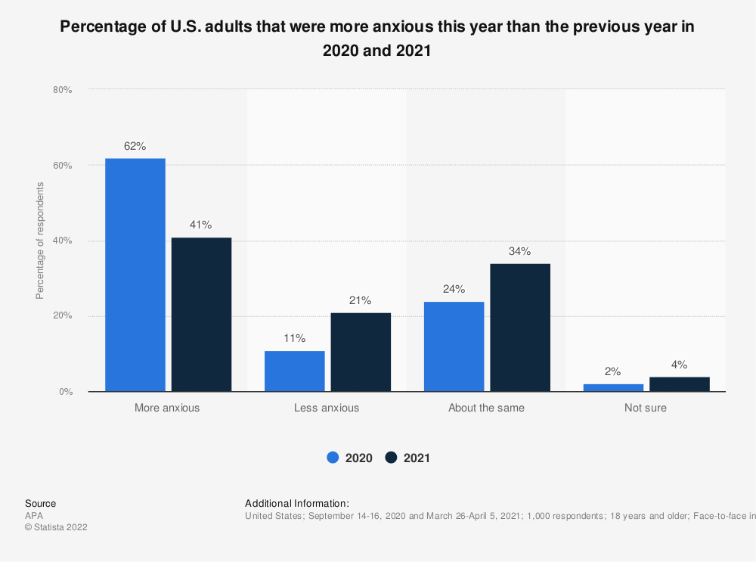
I referenced this statistic in the introduction, talking about anxiety levels in comparison to the pervious year.

