General Purpose: To Persuade

Specific Purpose: To persuade my audience that mass shootings need to be addressed by our legislative bodies.

Central Idea: Mass shootings have plagued our country and have become an increasingly dangerous problem as time has passed.

**Introduction**

I’d like to direct your attention towards this list [visual aid]. It contains some of the worst mass shooting events from 1982 to May of this year. It is ranked from highest casualties to the least. As you can see, the worst incident occurred in 2017 with the Las Vegas Strip Massacre, where 58 people were killed and around 550 people were injured. Out of the 25 incidents on the list, at least seven of them were in educational institutions. Even the campus we are standing on is at risk. Most of us have not been and will hopefully never be involved in these incidents. But after some research, I have concluded that we can’t just ignore this nagging issue. Something must be done. Mass shootings have become a detriment to our everyday life and our overall safety, and we must take it upon ourselves to fix it.

*But before we determine a course of action, we must discuss the problem and determine the stakes.*

**Body**

1. Mass shootings have become an increasingly large problem in our everyday life.
   1. According to this data reported by **Gale’s opposing viewpoints**, the number of mass shootings has increased since 2014.
      1. Just for reference’s sake, “…a mass shooting is defined as an incident in which four or more people are injured or killed, not including the shooter.
      2. If we take the shootings from 2021 and 2014, we see a substantial increase of these incidents by an appalling 260%. That’s more than double what was happening a decade ago.
      3. And since this graph was created at around July 4, we can be sure that the number of shootings this year has increased to an even larger number.
   2. Continuing the point of just how many lives we have lost due to these murders, **Susan Ladike** from the **CQ Researcher**, reported that there were a total of 611 deaths from the year of 2022.
      1. One of the infamous incidents this year was the mass shooting in Robb Elementary School in Texas on May 24, adding the other 12 deadly shootings according to the **Texas Tribune**. A total of 21 lives were put to an abrupt end.
      2. Schools are made to nurture the future of our nation, and yet, the kids who implicated in the Uvalde incidents will be forever scarred by violence.
      3. We can’t allow this to go on any longer.

*But to fix this, we have to be able to answer one question: what is causing this sharp rise in mass shooting incidents?*

1. The issue with mass shooting stems from two main causes.
   1. The first cause is the shooter’s rights to bear arms in the United States.
      1. Not only is it one of our basic rights, but **Britannica** writes that court precedent from District of Columbia v. Heller provides clarification by saying that “…the Second Amendment guarantees an individual right to possess firearm…and to use firearms for traditionally lawful purposes, including self-defense within the home”
      2. Under this precedent, it makes it clear that we as citizens are allowed to carry guns.
   2. The second cause is loose gun control and inconsistent regulations across all the states.
      1. According to this data compiled by **Luke McCoy** from **USA Carry**, our state allows resident and non-resident citizens to seek a firearm permit. Also notice that Texas uses the same regulations.
      2. When doing some research on the **Gun Law Navigator**, it states that federal law has not set a minimum required age to possess a shotgun or a rifle, and only about half of the U.S has set state laws that do regulate the age. (That’s not us by the way!) You only have to be eighteen to possess a firearm in 39 out of the 50 states.

*Now that we have identified what is causing the increased number of shootings, let’s establish some potential solutions.*

1. There are two big solutions, both of which require government action.
   1. First, we must contact our state representatives. After all, they are responsible for advocating policies into office.
      1. We must push for more uniform regulations for gun control.
      2. This includes setting the both the possession of firearms and the purchase of firearms at 21, or 18 at the least.
      3. Doing this gives federal agencies better control over what firearms we should possess.
   2. The second solution is to vote for the midterms this year (which yes, I know has already happened)
      1. Gun control is a big factor in this year’s election and is a point of contention among the Democrats and the Republicans
      2. But we must understand first that restricting what guns we can possess will help lower the number of incidents regarding gun violence, which includes mass shootings.
      3. Restricting what firearms we have works. If we just take a look at the firearm policy in another country like Australia, they restricted “…the ownership of automatic and semiautomatic rifles and shotguns…” according to another **Gale** article by **Adam Taylor and Amanda Coletta**. It brought down gun related incidents since that act was passed.

*Our legislative body in the federal government is the only function of the government that can employ such an action, and we must be the ones to push for it.*

**Conclusion**

And now, you should have a much better idea of the causes and solutions of mass shootings and gun violence. Violent is not something we talk about every day in our lives, but it is very important that we do not forgot about it. After all, school shootings have become reality for many elementary schools and students. Supporting gun control is about preventing lives from being ripped away and protecting our educational institutions. To protect our schools is to protect our future, but we have to take the first step.

Works Cited

Duignan, B. (2010, May 20). District of columbia v. Heller. Encyclopædia Britannica. Retrieved November 2, 2022, from https://www.britannica.com/event/District-of-Columbia-v-Heller

*This source is where I obtained information regarding the Heller v. District of Columbia court case*

Here's how other countries have responded to mass shootings. (2021, March 23). Washingtonpost.com, NA. <https://link.gale.com/apps/doc/A656032241/OVIC?u=tel_middleten&sid=bookmark-OVIC&xid=86f220e2>

*I used this source for information on how other countries use gun control*

Ladika, S. (2022, August 5). Gun violence. CQ researcher, 32, 1-32. <http://library.cqpress.com/>

*This source was used to provide the total number of deaths in the U.S. to mass shootings*

Mass Shootings in the United States during the First Six Months of 2022. (2022). In Gale Opposing Viewpoints Online Collection. Gale. <https://link.gale.com/apps/doc/JNJNLP622753977/OVIC?u=tel_middleten&sid=bookmark-OVIC&xid=cb2597dd>

*I used this source for the graphical information regarding the number of mass shootings over the years*

McCoy, L. (2022, October 1). Concealed carry permit reciprocity maps. USA Carry. Retrieved November 1, 2022, from https://www.usacarry.com/concealed-carry-permit-reciprocity-maps/

*I learned about resident and non-resident permits through this source.*

Mother Jones. (May 24, 2022). Number of victims of the worst mass shootings in the United States between 1982 and May 2022 [Graph]. In Statista. Retrieved October 22, 2022, from <https://www-statista-com.ezproxy.mtsu.edu/statistics/476101/worst-mass-shootings-in-the-us/>

*This labels the worst mass shootings as of August by the legality of their weapons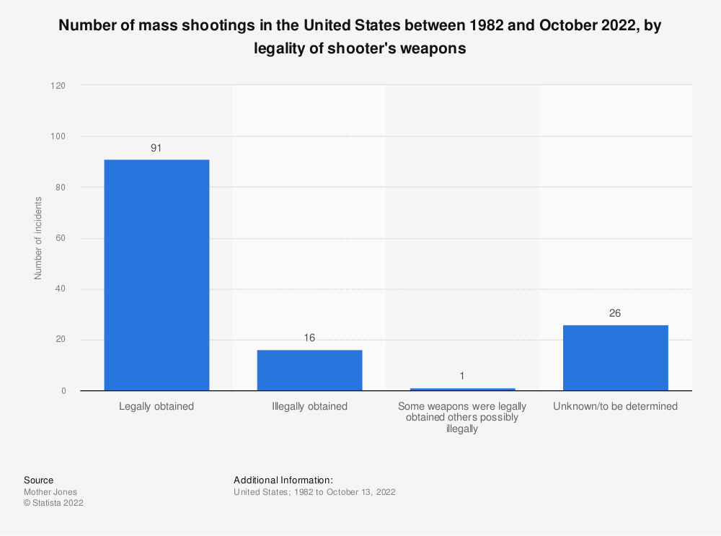*

N/A. (n.d.). Gun law navigator: Compare states. Everytown Gun Law Navigator. Retrieved November 1, 2022, from https://maps.everytownresearch.org/navigator/states.html?dataset=minimum_age&states=NY

*I learned about the lack of age regulation with possession of a shotgun or assault rifle through this source*

Park, B., Priest, J., Douglas, E., Zhang, A., & Dey, S. (2022, May 27). 21 lives lost: Uvalde victims were a cross-section of a small, mostly Latino town in South Texas. The Texas Tribune. Retrieved November 1, 2022, from https://www.texastribune.org/2022/05/25/uvalde-school-shooting-victims/

*This source provided information about the Uvalde shooting.*