**English 2030: Experiences in Literature / Prof. Lynn (Fall ’24)**

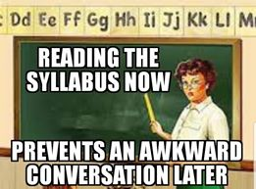

**Office:** Peck Hall 328C

**Office Hours:** MWF 7:00 am-7:45 am & 11:25 am-12:25 pm

**Phone:** (615) 892-4437 (If it’s an emergency, text between 6:00 am-5:00 pm *only.*)

**Email:** [Alyson.Muenzer@mtsu.edu](mailto:Alyson.Muenzer@mtsu.edu) (I check email several times, every day.)

**English 2030-00? meets [supply your classroom number and class meeting times].**

**Prerequisites:** a C- or better in English 1010 and 1020 (or the equivalent).

**Course Description and Policies:**

Welcome, students! Our classroom will be a student-centered environment, one where all students feel comfortable discussing, summarizing, and analyzing different works of literature with their peers. Throughout the term, we will study celebrated works from three major literary genres: short stories, poetry, and drama. We will contemplate who is eviler between Flannery O’Connor’s Misfit vs. Grandmother; discuss whether or not Robert Frost’s “The Road Not Taken” is an anthem celebrating independence vs. a commentary lamenting life’s choices; and explore The American Dream as seen through the eyes of Lorraine Hansberry’s fictional Younger family. This is just a small sampling of what’s to come; as your instructor, I am honored to take you on this literary journey.

**English 2030 is a True Blue Core course.**

* True Blue Core Knowledge Domain: Creativity and Cultural Expression (CCE) (9 hours)
* For all catalogs 2024-2025 and beyond, this course may be used to satisfy the True Blue Core Literature requirement (CCE) (3 hours). If you have already fulfilled the literature requirement for CCE, this course may be used in either Discovery or Explorations in the CCE category. To learn more about TBC requirements: <https://w1.mtsu.edu/truebluecore/core.php>.
* For all catalogs prior to 2024-2025, this course may be used to satisfy the literature requirement in the Humanities/Fine Arts category. To learn more about general education requirements for catalogs prior to 2024-2025: <https://w1.mtsu.edu/gen_ed/requirements.php>.
* **The TBC outcome for Literature (CCE):** Students demonstrate intercultural understanding by building knowledge, self-awareness, and conceptions of global and intercultural perspectives, values, systems, and attitudes.

### **Course Objectives:**

The following objectives are in alignment with the True Blue Core Knowledge Domain, Creativity and Cultural Expression:

* **Explore** how literature reflects, informs, and shapes both personal and collective experience.
* **Articulate** cogent responses to literature that demonstrate cultural awareness and understanding.
* **Reflect** on how reading, writing, and interpreting literature initiates and contributes to cultural and social conversations.
* **Examine** how the production and interpretation of literature is shaped by historical, cultural, and social contexts.
* **Analyze** how literature from different cultures, movements, and time periods employs narrative and stylistic strategies to convey complex ideas & meanings.
* **Compose** projects (written, digital, or audio) that utilize critical thinking, analysis, and research to situate literature within diverse cultural and conceptual frameworks.
* **Identify** connections between literature and the values, experiences, and practices of multiple cultures.
* **Develop** an approach to reading, writing, and interpretation that demonstrates an understanding of human experience from multiple cultural vantage points.

**Required Texts and Materials:**

Mays, Kelly J., ed. *The Norton Introduction to Literature* (Portable 13th ed.), Norton, 2020.

Access to D2L

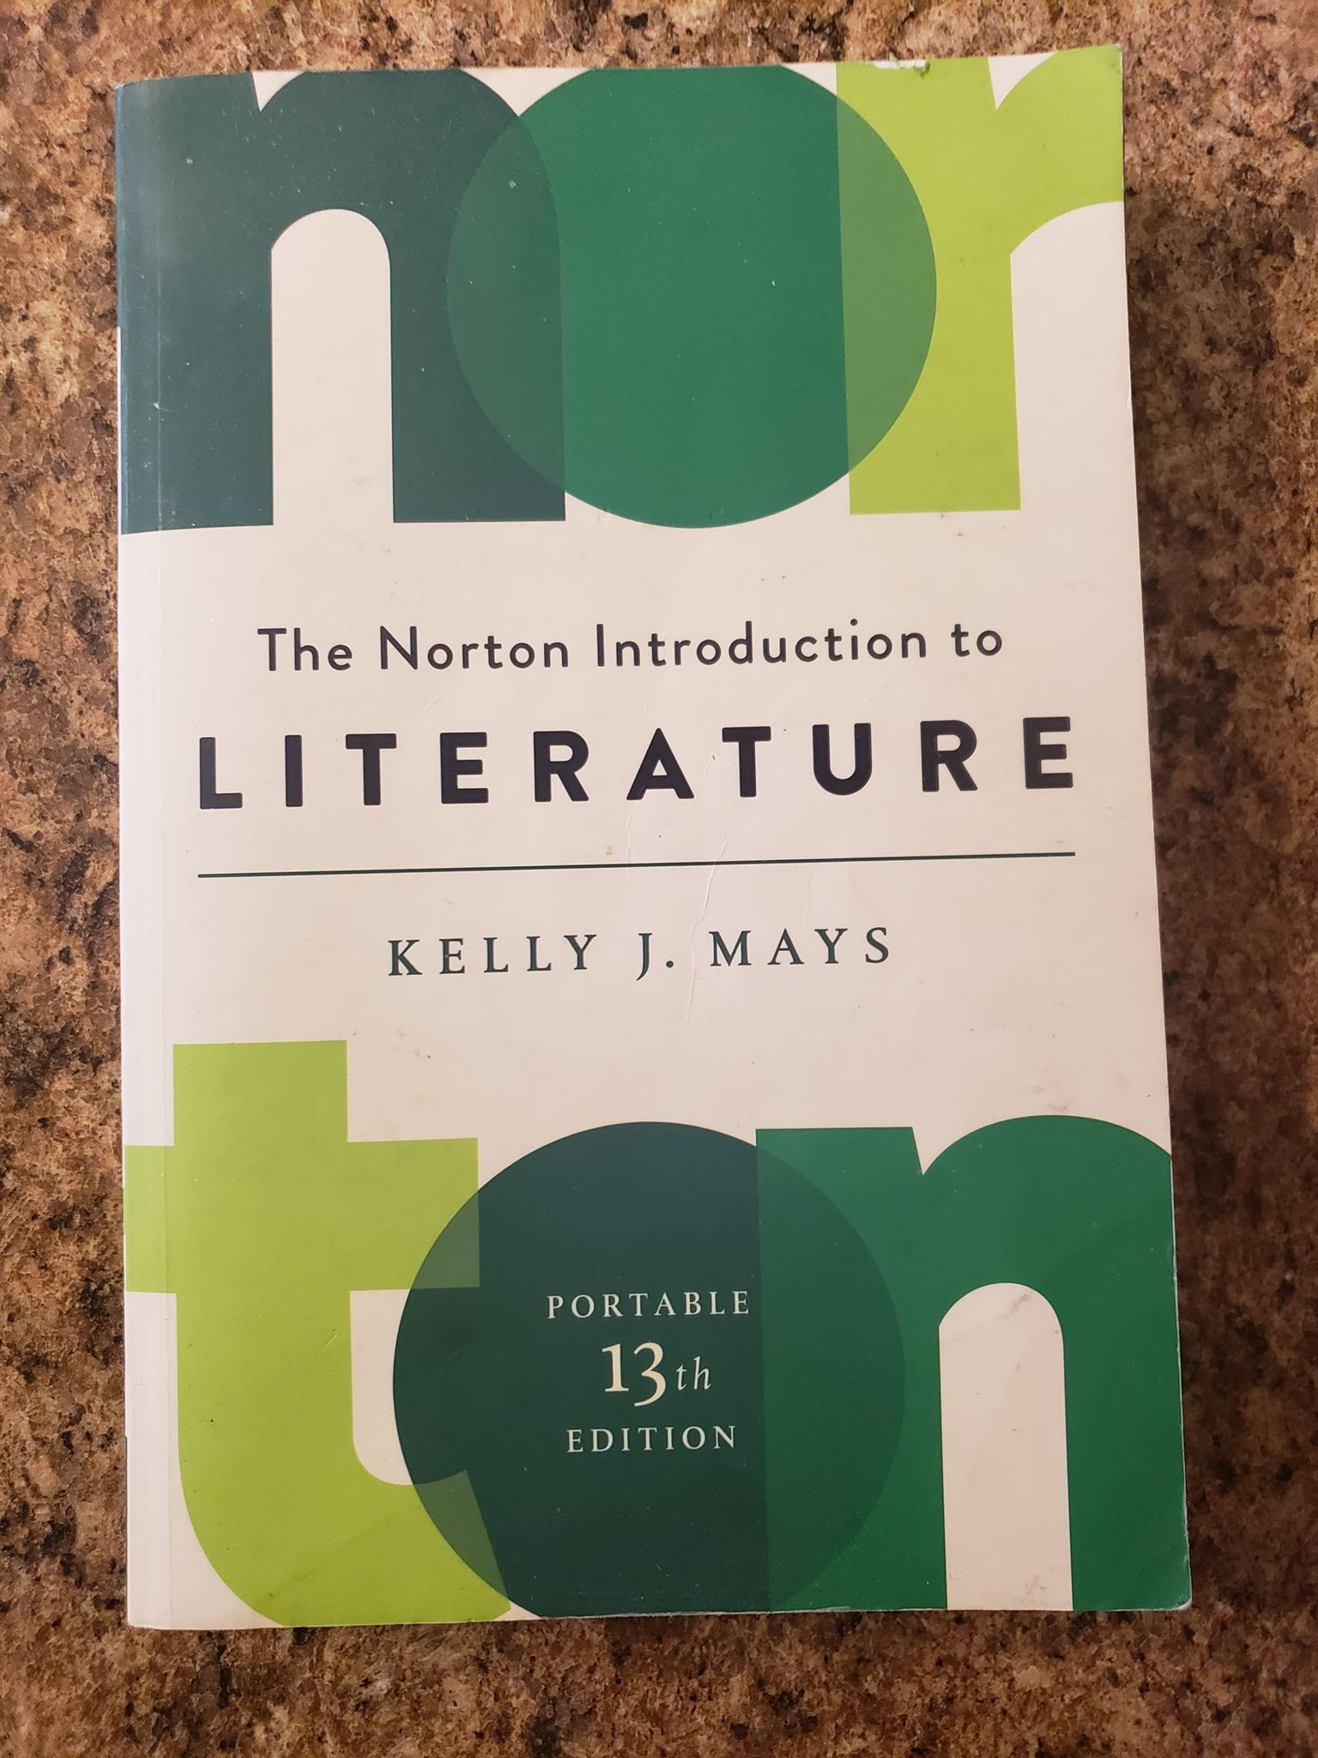

**Grading Policies:**

**Awarding a Course Grade:**

Two Unit Tests: 250 points (each test worth 125 points)

One Literary Analysis Essay: 200 points

One Time Travel Project: 250 points (paper worth 200 points, reflection component worth 50 points) *This is the True Blue Core Assessable Assignment.*

Twenty-one Reading Responses: 105 points (each response worth 5 points)

Five Drama Quizzes: 100 points (each quiz worth 20 points)

Scene from a Play Performance: 100 points

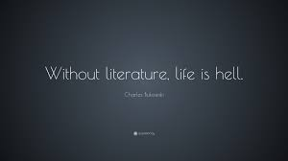

**Grading Scale:**

A=900-1,005 points

B+=870-890 points

B=830-869 points

B-=800-829 points

C+=770-799 points

C=730-769 points

C-=700-729 points

D+=670-699 points

D=630-669 points

D-=600-629 points

F=anything below 600 points

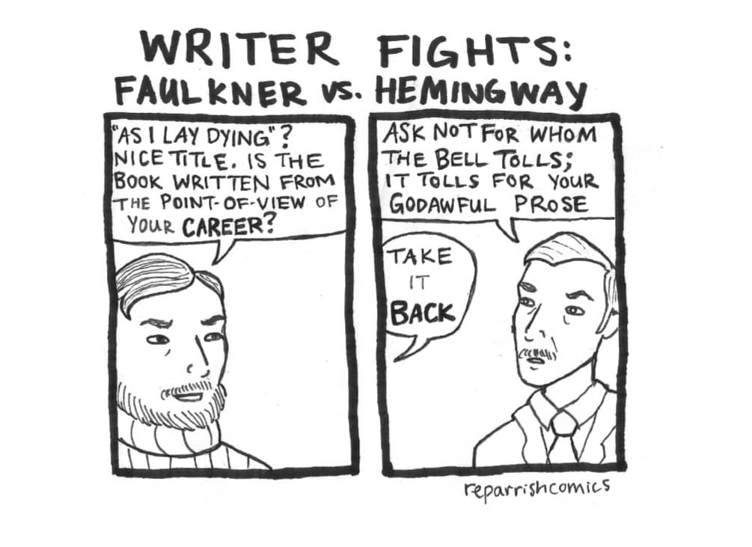

**Grading Expectations:**

When assessing your work, I will be looking for evidence of the following:

* Insight into your own cultural rules and perspectives and an awareness of how your own experiences have shaped those insights
* Understanding of and curiosity about members of other cultures in relation to history, values, beliefs, practices and the like—and how these shape interactions and inequalities within and across cultures
* Interpretation of more than one worldview and a demonstration of a manner that recognizes the feeling of another group

A heightened, sophisticated understanding of the above matters characterizes A and B-level work, whereas minimal awareness and/or surface understanding characterizes C and D-level work.

Exams will be graded and returned within one week, and papers will be evaluated and feedback offered within one to two weeks. Please come and talk to me (Peck Hall 328C), if you have any questions about your grades or my feedback.

**Incompletes:**

Incompletes will only be given in very rare circumstances (at the discretion of the instructor) when a student experiences a documented emergency at the end of the semester, which prevents them from completing the last of the required course assignments. In order to be considered for an incomplete, the student must have satisfactorily completed all of the previous assignments before the time of the emergency.

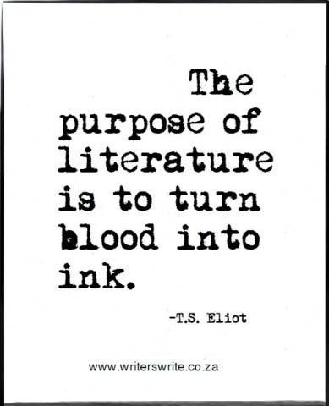

**The Reading and Discussion of Literature:**

English 2030 is a discussion / lecture course; therefore, I will assign multiple short stories, poems, and plays in order to facilitate lively, open-minded class discussions. Reading the assigned material, coming to class ready to discuss said material, and bringing an open mind to class discussions constitute the cornerstones of this 2030 course.

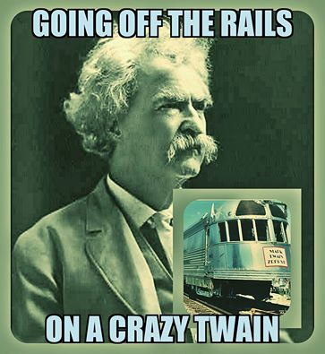

**\*ASSIGNMENTS AND POINT VALUES\***

**Two Unit Tests (250 total points):**

Students will complete two unit tests; one at the end of Unit 1, the other at the end of Unit 2. Exams will include a variety of matching and short answer questions, along with a more detailed quote / author identification section. Before each unit test, I will administer a practice test to help students prepare. *Tests can only be made up if the student presents **a reasonable excuse**\*.

**One Literary Analysis Essay (200 total points):**

At the end of Unit 1, students will compose a literary analysis that reflects on one or more of the assigned readings. The essay must be **at least** three full pages-long (not including the Works Cited). It must also feature an underlined thesis statement and incorporate appropriate parenthetical in-text citations as well as Works Cited entries. **Be advised that all essays are subjected to *TurnItIn*, which checks for plagiarism.**

**Time Travel Project (250 total points):**

In a nutshell, you will either bring a character from an assigned work into current-day society, or you will become a character and travel back in time—into a work of your choosing. A four-page minimum paper (200 points), plus a creative reflection with written component (50 points) are required.

**Five Unit 3 (Drama) Quizzes (100 total points):**

During Unit 3, I will administer five reading quizzes covering the three assigned plays. Each quiz (ten multiple choice questions) will have a ten-minute time limit and will be handed out **at the beginning** of class. If a student is five minutes late for class on a day when I administer a quiz, said student will then have only five minutes to complete the quiz. I do NOT give make-up quizzes.

**Scene from a Play Performance (100 total points):**

On the last day of class prior to the final exam, students will perform a chosen scene from one of the three assigned plays. Working in groups of 3-4, all students will act as a character (or two, if necessary). While lines do not have to be memorized, students are encouraged to practice line delivery. Other requirements include the selection and use of three props as well as one modification to the chosen scene.

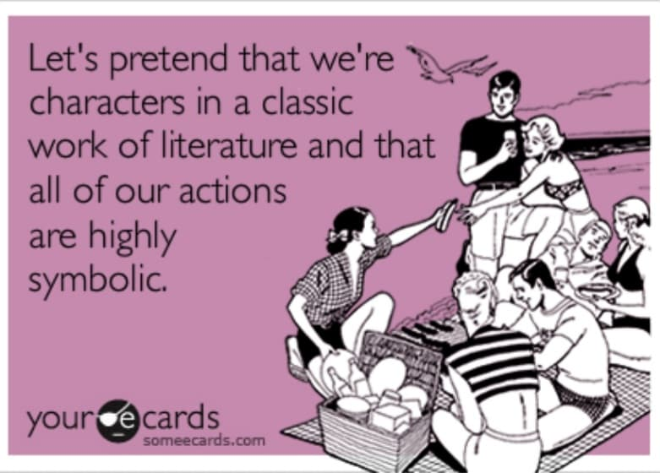

**Reading Responses (105 total points):**

As it’s explicitly stated throughout your assignment schedule, you will be composing responses for all readings. Each one is worth 5 points, and I assign a total of twenty-one. You will receive a zero if you don’t generate the required sentence-length or if you plagiarize your responses (**seriously, do not do that**). Often, I will bring up your summaries in class, so please submit only original summaries. In the event that you cannot attend class, you can still get credit for your summaries *as long as you email your work before the end of class.*

**Participation in Small-group Discussions:**

I believe in the power of group work. I also believe that some students take advantage of others, opting to use their phones or complete work for another class when they should be helping their group. I do **not**, however, believe in assigning “busy work” only for the sake of keeping you busy. In-class discussion work will be relevant to what we are learning, and students are expected to work together--as a cohesive unit.

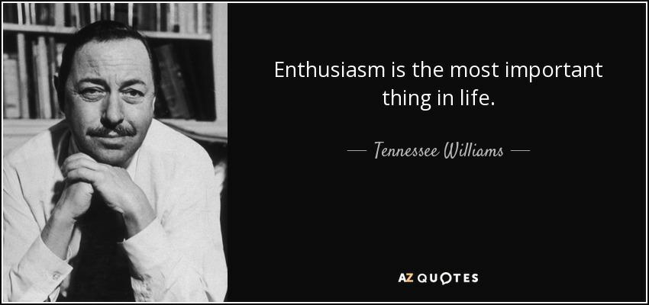

**Attendance:**

My MW students can miss up to 4 periods before their grades are affected, for 4 periods equal two full weeks. For each additional absence, students will lose 20 points from their final course grade. **Missing more than 8 classes will make you ineligible to pass the course—no exceptions.**

Students are expected to keep their instructors as informed as possible regarding their status when they are absent from class and act with good faith and honesty when determining whether or not they should attend class. Students who must miss more than two (2) weeks of regularly scheduled classroom instruction should speak with their professor(s) immediately and also consult with an enrollment coordinator in MT One Stop for guidance to determine if withdrawing is in their best interest. **Non-attendance in class does not relieve students of the responsibility for work covered or assigned in their absence.**

**Late Arrivals:**

Students who are habitually late to class disrespect both their instructors as well as their classmates, so *for that reason alone*, don’t be late.

### **Attendance Reporting:**

MTSU Administration requires that instructors complete an attendance report for each course each semester. There are financial aid implications for non-attendance.

### **Email:**

Please email me at [Alyson.Muenzer@mtsu.edu](mailto:Alyson.Muenzer@mtsu.edu) (but don’t forget, my last name is Lynn). With rare exceptions, I will respond to all emails within 24 hours. Make sure to have an email classroom buddy, in addition to me, if you have questions about missed work or deadlines. Also, visit me during office hours – I’m happy to answer questions about class, give you feedback, share literature wisdom, etc.

**Academic Integrity:**

Plagiarism, cheating, and other forms of academic dishonesty are prohibited. Students guilty of academic misconduct, either directly or indirectly, through participation or assistance, are immediately responsible to the instructor of the class. In these instances, the faculty member has the authority to assign an appropriate grade for the exercise or exam, or to assign an F in the course, as is proportional to the nature and extent of said academic misconduct. When assigning a grade based on academic misconduct, the faculty member shall ensure that the students are made aware of their appeal rights.

Student writers must give credit for text, ideas, and images that did not originate with them. The student handbook differentiates between unintentional and intentional plagiarism. Unintentional plagiarism, or misuse of sources, is a “teaching moment”; intentional plagiarism--such as downloading a paper, having someone else (such as a tutor or girl/boyfriend) write the essay, or cutting & pasting with no acknowledgement of the source--is a form of academic misconduct.

As your instructor, I am required to report *severe* instances of academic misconduct to the Director of Academic Integrity. In our class, sanctions range from a mandatory re-write for partial credit to an F in the course. To avoid such penalties, always do your own work, and ask for help when using source material. You can get said help in class, during my office hours, at the University Writing Center, or online at Purdue’s OWL.

**P.S. I do not recommend the use of ChatGPT or anything similar. If you can’t bring yourselves to read and then respond in your authentic student voice, you should seriously consider why you’re even attending college.**



## Inclusive Learning Statement:

Your success in this class is important to me. If there are aspects of this course that prevent you from learning or exclude you, please let me know as soon as possible. Together we’ll develop strategies to meet both your needs and the requirements of the course.

**Statement on Behalf of Students with Disabilities:**

Middle Tennessee State University is committed to campus access in accordance with Title II of the Americans with Disabilities Act and Section 504 of the Vocational Rehabilitation Act of 1973. Accommodation requests, both temporary and permanent, are determined by The Disability & Access Center, and if the DAC can assist you, there are ways to reach out: via phone at (615) 898-2783 or via email at dacemail@mtsu.edu. **Please understand that I am always willing to discuss accommodations at any time.**

**Lottery Scholarships Statement:**

Students that wish to retain Tennessee Education Lottery Scholarship (TELS) eligibility must earn a cumulative TELS GPA of 2.75 after 24 and 48 attempted hours and a cumulative TELS GPA of 3.0 thereafter. A grade of C, N, F, or I may negatively impact TELS eligibility. If you drop this class, withdraw, or if you stop attending this class, you may lose eligibility for your lottery scholarship, and you will not be able to regain eligibility at a later time. For additional lottery rules, please refer to your Lottery Statement of Understanding form (http://mtsu.edu/financial-aid/forms/LOTFOD.pdf) or contact your MT One Stop Enrollment Counselor (http://mtsu.edu/one-stop/counselor.php).

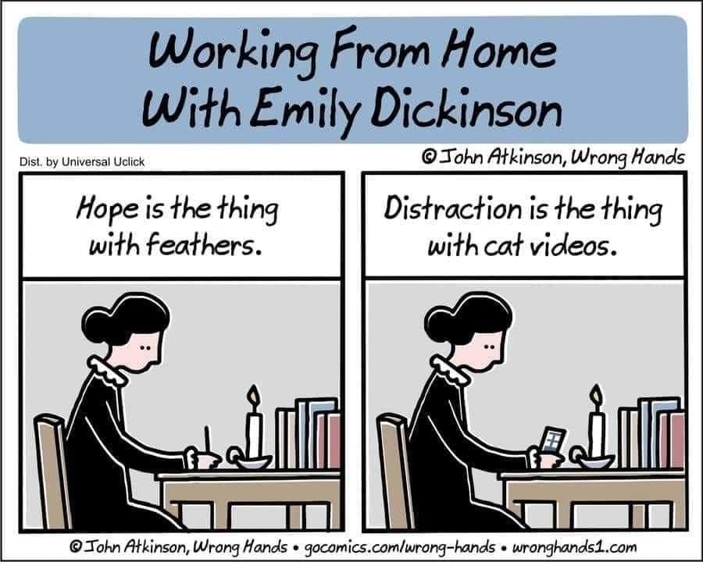

**University Writing Center (UWC):**

At the UWC, student writers receive valuable one-on-one tutoring, from simple matters such as editing comma splices, to more complex matters such as organizing and developing essay ideas. Do understand, though, that the UWC is **not** simply a proofreading service. Be sure to avoid waiting until the last minute to schedule an appointment, and I always recommend taking a copy of the essay assignment so that tutors have a better understanding of how they can assist. The UWC is located in James E. Walker Library 362; the phone number is (615) 904-8237 and their website address is www.mtsu.edu/uwc.

**Sources for Counseling and Psychological Services:**

The MTSU Counseling Services office is located in room 326-S of the KUC and is a *free* service for all students. Located at Miller Center for Education (503 East Bell St. Suite 100) is MTSU’s Center for Counseling & Psychological Services; this service is also free to students (and staff), and community members pay only $10. Also, the *National Suicide Prevention Lifeline* will automatically connect you with a certified local crisis center 24 hours a day, 7 days a week.

**Inclement Weather / Class Cancellations:**

If the weather is questionable (meaning more than a few drops of rain or chilly temps), I would want you to use your best judgement before coming to class. If I cannot make it to class for any reason, I will send you a timely D2L announcement and ensure that signs are posted on the classroom door.



**Classroom Behavior:**

Please treat me the same way I treat all students--with respect, tolerance, and patience. Examples of disruptive classroom behaviors are talking while others are talking, wearing ear buds at any time during class, checking social media, shopping for shoes online, completing work for another class, texting or sending emails, consistently arriving late, and packing up materials before class is officially dismissed. In our classroom, I like to have as much fun as each class period allows, so hopefully students won’t feel the need to engage in these disruptive behaviors. Ideally, our classroom will be a lively, yet organized environment, as well as one where differing opinions are respected. *Don’t be a Moby Dick.*

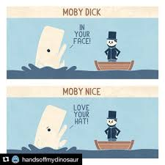

## Right to Make Changes Statement:

## Please understand that as your instructor, I reserve the right to make changes to the assignment schedule if necessary. I promise, however, that said changes will be fair.

**Some Important Dates:**

Aug. 26: First Day of Class

Sept. 2: Labor Day – No Class/University Closed

October 12-15: Fall Break – No Classes

Nov. 27-30: Thanksgiving Break – No Classes

Dec. 5: Study Day

Dec. 6-12: Final Exams

Dec. 15: Deadline for Final Grades

**English 2030 Syllabus Review Sheet / Prof. Lynn (Spring ‘24)**

1. Where is my office located? Which days of the week and at what times can you find me there?

2. What is the title of our required text?

3. What can you tell me about the Literary Analysis essay? How many points is it worth?

4. What can you tell me about the Time Travel project? How many points is it worth?

5. How many unit tests do I administer? How many points is each worth?

6. How many quizzes will you take? When will they be given? How many points is each worth? Are make-up quizzes allowed?

7. What can you tell me about the required Scene from a Play Performance?

8. How many reading responses will you complete? What is the TOTAL number of points for this grade?

9. Summarize the attendance policy.

10. Trying your best to answer *in your own words*, what is the difference between unintentional and intentional plagiarism? What might happen if you are found guilty of the latter?

11. What is the UWC and where is it located?

12. What are two examples of disruptive classroom behavior?

13. Ask me a question about anything.