English 2030 Assignment Schedule (Petrovich / Fall ‘24)
Note: For works not in The Bedford, you will find them either listed under content in D2L OR linked within the schedule. You are to read the work for each day prior to each class. In order to take part in class discussions, always bring the textbook or other required readings to class (on your laptop is fine). Thanks in advance for your understanding!
Each Wednesday and Friday, you will do an in-class Lit Log entry on D2L. Each entry is worth 10 points, and there are a total of 25 entries. If you must miss class, you must communicate with me prior to missing in order to make up a missed Lit Log entry.
Week 1
Monday, August 26
- Distribute / briefly discuss course syllabus & schedule.
- Play a fun game to get to know each other!
Wednesday, August 28
- What is literature?
- Frankenstein- Preface and Letters I-IV (link: https://romantic-circles.org/editions/frankenstein/editions.2009.frankenstein.1818.html)
- Judge a Book by Its Cover Activity
- First Lit Log
Friday, August 30
- Frankenstein- Volume 1: Chapters 1-3
- Lit Log

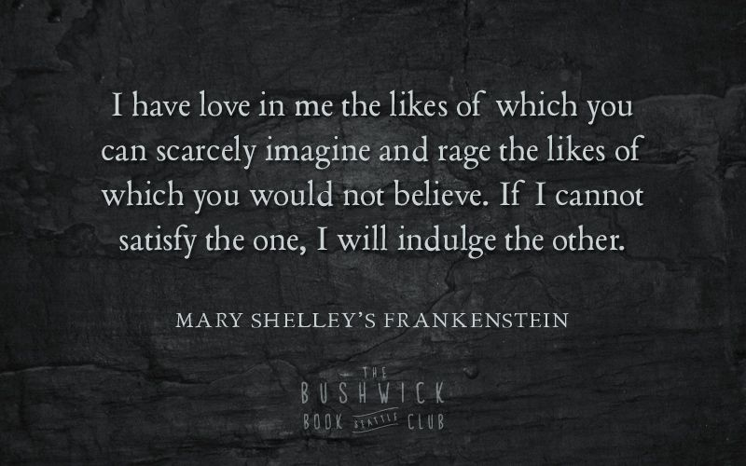
Week 2
Monday, Sept. 2
LABOR DAY!! NO CLASS!
Wednesday, Sept. 4
- Frankenstein- Volume 1: Chapters 3-7 (end Volume 1)
- Lit Log
- Students’ Choice—Begin watching Frankenweenie, Lisa Frankenstein, or play The Wanderer as a class.
Friday, Sept. 6
- Frankenstein-Volume 2: Chapters 1-4
- Lit Log
- Continue with Students’ Choice

Week 3
Monday, Sept. 9
- Frankenstein-Volume 2: Chapters 4-9
- Continue with Students’ Choice
Wednesday, Sept. 11
- Frankenstein-Volume 3: Chapters 1-4
- Lit Log
- Continue with Students’ Choice
Friday, Sept. 13
- Frankenstein-Volume 3: Chapters 4-7 and “Walton in Continuation” (Finish the book)
- Finish Students’ Choice
- Lit Log
Week 4
Monday, Sept. 16
- Read Vladimir Nabokov’s short story, “Terror,” and H.P. Lovecraft’s “The Outsider” (both stories are on D2L)
- Identity activity/discussion of identity
- Watch short film The Outsider in class
Wednesday, Sept. 18
- Read Edgar Allan Poe’s “The Cask of Amontillado” (pg. 481 Bedford)
- Read Guy de Maupassant’s “The Hand”
- Discussion of narrators—reliable or unreliable?
- Lit Log
Friday, Sept. 20 
- Read Kate Chopin’s “The Story of an Hour” (pg. 15 in Bedford)
- Read Edith Wharton’s “The Lady’s Maid’s Bell” (on D2L)
- Discussion of gender roles, identity, feminism, and the gothic heroine.
- Lit Log
ONE PAGER ASSIGNMENTS DUE BY CLASSTIME! BEGIN PRESENTATIONS.
Week 5
Monday, Sept. 23
CONTINUE ONE-PAGER PRESENTATIONS
- Read William Faulkner’s “A Rose for Emily” (pg. 40 in Bedford)
- Discussion of Southern Gothic
Wednesday, Sept. 25
- Read Flannery O’Connor’s “A Good Man is Hard to Find” (pg. 279 in Bedford)
- Read Shirley Jackson’s “The Lottery” on D2L
- Scenes from The Hunger Games
- Lit Log
Friday, Sept. 27
- Read Ursula K. Le Guin’s “The Ones Who Walk Away from Omelas” (pg. 116 in Bedford)
- Scenes from The Hunger Games
- Lit Log

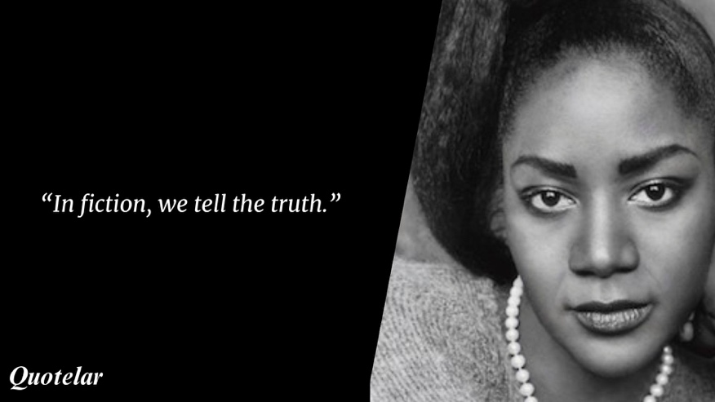
Week 6

Monday, Sept. 30

- Read ZZ Packer’s “Drinking Coffee Elsewhere” (pg. 426 in Bedford)
- Begin watching A Conversation on Race short films

Wednesday, Oct. 2

- Read Toni Morrison’s “Recitatif” on D2L
- Continue A Conversation on Race
- Lit Log

Friday, Oct. 4

- Finish and Discuss A Conversation on Race
- Lit Log
CHARACTER ANALYSIS DUE BY 11:59 PM

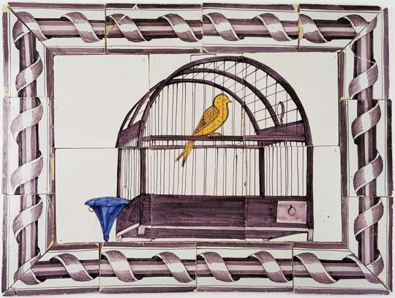

Week 7

Monday, Oct 7

- Read Susan Glaspell’s play Trifles (pg. 975 in Bedford)
- Discussion of drama
- Genre twist activity.

Wednesday, Oct. 9
- Read Act One of Tennessee Williams Cat on a Hot Tin Roof on D2L
- Lit Log
Friday, Oct. 11
- Read Act Two of Cat on a Hot Tin Roof on D2L
- Lit Log
Week 8
Monday, Oct. 14
FALL BREAK!!!
Wednesday, Oct. 16
- Finish Cat on a Hot Tin Roof on D2L
- Lit Lot
Friday, Oct. 18
- Read Amiri Baraka Dutchman on D2L
- Watch Dutchman adaptation (1967)
- Lit Log
Week Nine
Monday, Oct. 21
- Finish watching Dutchman
- Work on Creative Writing Adaptation in class.
Wednesday, Oct. 23
- Ms. P Conference: Watch Video on D2L. Work on Creative Writing Adaptation
- Lit Log—You spin yourselves and do whatever each of you land on!
Friday, Oct. 25
- No Class-Ms. P conference: Work on Creative Writing Adaptation

Week 10
Monday, Oct. 28
- Ms. P Conference—NO CLASS!
- CREATIVE WRITING ADAPTATION DUE BY 11:59 PM!
Wednesday, Oct. 30
- Read Edgar Allan Poe “Annabel Lee” (pg. 954 in Bedford)
- Read Edgar Allan Poe “The Raven” on D2L
- Peck Hall Horror Hunt (Haunt) Activity and Discussion
- Lit Log
Friday, Nov. 1
- Read Emily Dickinson “I’m Nobody, Who Are You?,” (on D2L) “If I Shouldn’t Be Alive,” (pg. 725) and “Because I could not stop for Death” (736)
- Poetry Gallery Walk Activity
- Lit Log
Week 11
Monday, Nov. 4
- Read T.S. Eliot’s “The Love Song of J. Alfred Prufrock” (pg. 938)
Wednesday, Nov. 6
- Read Robert Frost “Desert Places,” (pg. 773) and “Out, Out—” (pg. 766)
- Poetry as a picture in-class activity
- Lit Log
Friday, Nov. 8
- Read E.E. Cummings’s “O sweet spontaneous” (pg. 667) and “anyone lived in a pretty how town” (on D2L)
- Discuss form.
- Lit Log
Week 12
Monday, Nov. 11
- Read Langston Hughes’s “Harlem,” (pg. 589) and “Ballad of the Landlord” (pg. 854)
Wednesday, Nov. 13
- Read Gwendolyn Brooks’ “We Real Cool” (pg. 670) and Lucille Clifton’s “cream of wheat” on D2L
- Lit Log
Friday, Nov. 15
- Read Allen Ginsberg’s “Howl” (on D2L) and “Sunflower Sutra” (pg. 898)
- Lit Log
Week 13
Monday, Nov. 18
- Read Sylvia Plath’s “Tulips” (on D2L), “Pheasant” (pg. 900), and Gail White’s “Dead Armadillos” (pg. 893)
Wednesday, Nov. 20
- Read Adrienne Rich’s “Diving into the Wreck” on D2L
- Lit Log
Friday, Nov. 22
- Read Julia Alvarez’s “First Muse” (pg. 826) and “Sometimes the Words Are So Close” (pg. 822)
- Lit Log


Week 14
Monday, Nov. 25
- Bring your favorite song lyrics to class.
- Read Bob Dylan’s “It’s Alright, Ma (I’m Only Bleeding) (pg. 875), Van Morrison’s “Astral Weeks,” (pg. 881), Janelle Monae’s “Americans” (pg. 887), and Bruce Springsteen’s “Born in the USA” (on D2L)
Wednesday, Nov. 27
- HAPPY THANKSGIVING! NO CLASS!
Friday, Nov. 29
- NO CLASS!
Week 15
Monday, Dec. 2
- Wrapping up song lyrics as literature.
- In class reading
Wednesday, Dec. 4
- Time to work on Time Travel Project.
Final Exam
Wednesday, Dec. 11
- During our Final Exam period, Wednesday, December 11 (7:30-9:30 AM), students will share their creative reflections from the Time Travel project with their classmates. Do understand in advance that failure to present at your scheduled time will result in a zero (out of 100 possible points).

