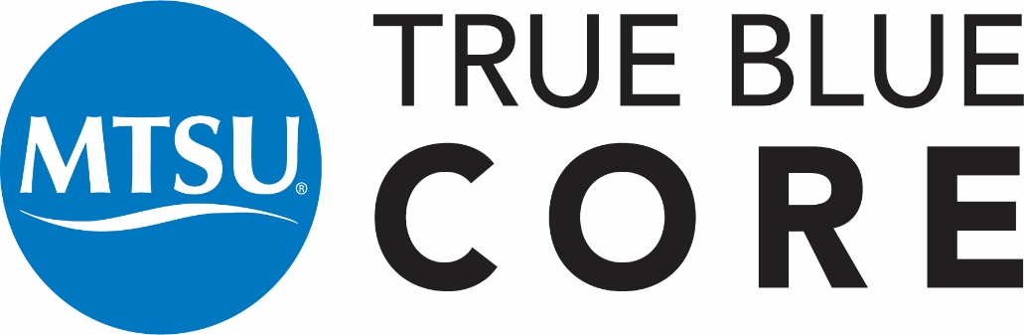

ENGL 1020: Research Writing and Argumentation Syllabus (3 credit hours)

INSTRUCTOR INFORMATION
Your name, email, and office number here

Student Hours
1 hour per course and by appointment.

Course Information
Welcome to ENGL1020! English 1020 is the second in a two-semester first-year composition sequence that prepares you with questions and rhetorical awareness to approach the many and varied kinds of writing situations you will encounter in the future. This semester, we will build on previous writing experiences to discover and refine our own most effective writing habits, learn new strategies for writing in a variety of contexts, and develop a broader understanding of how researched writing works. We will focus on reading texts rhetorically, using sources responsibly, and communicating ideas effectively for specific purposes and audiences.
ENGL 1020 is a part of the True Blue Core and focuses on D2: Information Literacy. Information literacy is the ability to know when there is a need for information and to be able to identify, locate, evaluate, and effectively and responsibly use and share that information for the problem at hand. Information literacy assumes a broad definition of information, including but not limited to print, digital, media, technology, scientific, artistic, and other types of information.
Course Objectives
In ENGL1020, students will:
Conduct secondary research that relies on recursive relationships between reading, writing, and reflection (Composing Processes);
Practice flexibility and awareness of effective delivery across different audiences, contexts, and genres (Rhetorical Knowledge);
Locate sources and analyze their relevance and credibility (Genre Conventions);
Demonstrate rhetorical understanding of source attribution (Information Literacy).
Interpret and respond to complex ideas in secondary sources (Reading);
Identify connections between coursework and other academic and external contexts (Integrative Thinking);
Topics Covered
Topics in the course include, but are not limited to:
Proposing Research, Working With Sources, Composing Research Projects, Presenting Research Projects
Course Projects
Project 1: Research Project Proposal
The purpose of this assignment is to engage in an authentic, exciting research project that draws attention to related research processes such as asking questions, selecting appropriate methods, identifying critical conversations, and proposing a project. Select a research project important to you, one that responds to a research question to which you do not already know the answer.
Project 2: Source Work
For this project, please deeply read, reflect on, integrate, and cite secondary research.
Project 3: Research Project
In this project, you are invited to integrate all of your work thus far together in a research essay. Attend to effective rhetorical argumentation, ethical citation conventions, and engagement in scholarly conversations. This usefully applies the focus on rhetorical genre developed in ENGL1010 and Information Literacy skills transferable to contexts beyond the English classroom.
Project 4: Research Presentation
Research is meant to be shared! For this final project of the semester, share research findings in a remediated presentation of Project 3 work. Create a tangible artifact, poster, film, or podcast that shares your work in an accessible form meant to engage an audience of your peers.
Course Materials
Students will be provided free access to the The Ask: A More Beautiful Question at
https://mtsu.pressbooks.pub/1020mtsu/. If you would like a hard copy, you can print it out.

ASSESSMENT AND GRADING
In order to earn General Education credit for this course, you must earn a C- or better. If students receive a grade below a C-, they will need to retake the course to earn True Blue Core credit. The following is a description of the criteria used in assigning final letter grades:
A—Work of distinctly superior quality and quantity accompanied by unusual evidence of achievement
B (B+, B, B-)—Work of good quality and quantity accompanied by evidence of achievement beyond the essentials of a course
C (C+, C, C-)—Work demonstrating fulfillment of the essentials of a course
D (D+, D, D-)—Passing work, but below the standards of graduation quality
F—Failure, necessitating repetition of the course to obtain credit
FA—Failure (and stopped attending)
I—Incomplete (not used in calculating grade point average)
W—Assigned in courses that are dropped during a specified period of time within a term. Students should consult online for specific dates each term here: https://www.mtsu.edu/calendar_academic.php
More information is available at https://www.mtsu.edu/grades-and-transcripts/index.php
Assessment Procedure
There are three different types of written work in the course: invention assignments (daily work), writing projects (extended writing assignments for which revision is possible), and revised projects (final, polished versions of writing projects). Students earn grades in the course commensurate with the work they complete in each of the categories of written work.
Feedback
[Describe Feedback practices; example below]
I will provide audio feedback with written transcripts on all formal Writing Projects within one week of submission. Please let me know in writing if you prefer a different method of feedback.
- Assignments must be submitted to the Dropbox and will not be accepted via email.
- Assignment deadlines are available in the D2L Dropbox, on the calendar, and in checklists.

Participation

Class Participation
This is a small, workshop-based class, so come to class. Come to class on time. It will be lonely and weird if you don’t attend. However, if you’re sick, don’t come to class. We want you, but we don’t want your germs. It’s essential to come to class to be successful in coursework – otherwise you won’t know what’s going on.

Inclusive Learning Statement
Your success in this class is important to me. We will all need accommodations because we all learn differently. If there are aspects of this course that prevent you from learning or exclude you, please let me know as soon as possible. Together we’ll develop strategies to meet both your needs and the requirements of the course.
I encourage you to visit the Disability and Access Center to determine how you could improve your learning as well. If you need official accommodations, you have a right to have these met. There are also a range of resources on campus, including the Writing Center, Counseling Center, and Academic Advising Center.

Email
Please email me at my MTmail account: X. With rare exceptions, I will respond to all email within 48 hours. Make sure to have an email buddy who you can email in addition to me if you have questions about missed work or deadlines. Also, visit me during office hours – I’m happy to answer questions about class, give you feedback on drafts, share limited writing wisdom, etc.

Attendance Reporting
MTSU Administration requires that instructors complete an attendance report for each course each semester. There are financial aid implications for non-attendance.

Student Resources

The Margaret H. Ordoubadian University Writing Center
The Margaret H. Ordoubadian University Writing Center is located in LIB 362 and online at www.mtsu.edu/writing-center. Here, students can receive valuable (and FREE!) one-to-one assistance on writing projects for any course. Conferences are available by appointment (615-904-8237). Visit early and often!

Technical Support
D2L Resources are available to MTSU Online Students. You can also find help for the basic D2L functions used most often directly in your D2L course under the D2L Help for Students module.

Students with Disabilities
Middle Tennessee State University is committed to campus access in accordance with Title II of the Americans with Disabilities Act and Section 504 of the Vocational Rehabilitation Act of 1973. Any student interested in reasonable accommodations can consult the Disability & Access Center (DAC) website and/or contact the DAC for assistance at 615-898-2783 or DAC Email

Tutoring
The Margaret H. Ordoubadian University Writing Center is located in LIB 362 and online at www.mtsu.edu/writing-center. Here, students can receive valuable (and FREE!) one-to-one assistance on writing projects for any course. Conferences are available by appointment (904-8237). Visit early and often!

Title IX
Students who believe they have been harassed, discriminated against or been the victim of sexual assault, dating violence, domestic violence or stalking should contact a Title IX/Deputy Coordinator at 615-898- 2185 or 615-898-2750 for assistance or review MTSU’s Title IX website for resources.
MTSU faculty are concerned about the well-being and development of our students and are legally obligated to share reports of sexual assault, dating violence, domestic violence and stalking with the University’s Title IX coordinator to help ensure student’s safety and welfare. Please refer to MTSU’s Title IX website or contact information and details.

