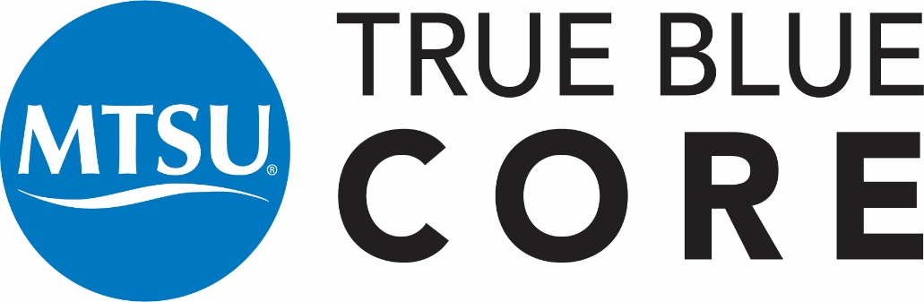

ENGL 1010: Expository Writing Syllabus (3 credit hours)

INSTRUCTOR INFORMATION
Your name, email, and office number here

Student Hours
1 hour per course and by appointment

Course Information
Welcome to ENGL1010! English 1010 is the first in a two-semester first-year composition sequence that prepares you with questions and rhetorical awareness to approach the many and varied kinds of writing situations you will encounter in the future. In Expository Writing you will gain grounded, practical experience with the conventions of academic discourse. Together we will investigate how effective writers write in and beyond college, what successful writing looks like, and how specific practices, strategies, and concepts will aid you in becoming a more flexible, adaptive, and skillful communicator at MTSU and beyond.

True Blue Core (TBC) Written Communication (WC)
For all catalogs 2024-2025 and beyond, this course (ENGL 1010) satisfies the True Blue Core (TBC) curriculum requirement (3 hours) for Written Communication (WC). To learn more about TBC requirements: https://w1.mtsu.edu/truebluecore/core.php.

For all catalogs prior to 2024-2025, this course (ENGL 1010) satisfies one of the general education curriculum requirements for Communication (3 of 9 hours). To learn more about general education requirements for catalogs prior to 2024-2025: https://w1.mtsu.edu/gen_ed/requirements.php.

Course Objectives and TBC Outcome
The TBC outcome for Written Communication: Students communicate effectively through writing in terms of context and purpose, content development, genre and disciplinary conventions, sources and evidence, and syntax and mechanics.
In ENGL1010, students will:
Examine multimodal literacies across contexts, cultures, and communities, including academic disciplines and public audiences (Reading processes)
Reflect on literacy in student lives and across learning experiences (Integrative Thinking) Compose writing tasks that demonstrate understanding of the rhetorical situation (Rhetorical Knowledge);
Revise writing assignments based on iterative feedback and make appropriate decisions about content, form, and presentation (Composing Processes)
Demonstrate understanding of ethical primary research practices (Genre Conventions)
Practice genre analysis of various types of text—print, digital, and audio (Information Literacy)
Topics Covered
Topics in the course include, but are not limited to:
Composing Processes, Reading Processes, Genre Conventions, Rhetorical Knowledge, Integrative Thinking, Information Literacy

Course Projects
Project 1: Personal Literacy
The purpose of this Multimodal Literacy Narrative assignment is to draw attention to you and your classmates as literate individuals, writers and rhetors who have made many informed decisions about composition throughout your lives. Through building metacognitive awareness, this project introduces you to each other, to me as your instructor, and writing at the university level. It also helps you to see discourse as constructed and rhetorical, key components of the course and later success as a flexible, strategic writer.
Project 2: External Literacy
In this Primary Research project, I ask you to begin to look outside yourself, bringing your burgeoning rhetorical awareness and literacy understanding to primary research opportunities. Adopting primary research methods as a bridge to conversations about source-use, this composition asks you to draw on your findings to craft a window into someone else’s literacy experiences.
Project 3: Networked Literacies (TBC Assessable Assignment)
In this Genre Analysis project, I ask you to draw on your literacy learning in Projects 1 and 2 to guide your exploration of how literacy functions more broadly, in communities. In particular, you’ll need to examine genres rhetorically, considering how community literacies are expressed through genre. Genres function like cultural artifacts, demonstrating their needs, values, and expectations through discourse. You might focus on one genre in particular, or you might examine myriad genres of a particular community, such as that of a particular university community, major, or discipline.

Project 4: Integrated Literacy Reflection
In this Reflective Presentation project, mindfully reflect on your work from across the semester and develop an attendant reflection on Written Communication.
Course Materials
The required text for the class is a free, open educational resource (OER): The Muse: Misunderstandings and Their Remedies (https://mtsu.pressbooks.pub/engl1010/). You may download and print the text from the site if you would like a hard copy.

ASSESSMENT AND GRADING
In order to earn General Education credit for this course, you must earn a C- or better. If students receive a grade below a C-, they will need to retake the course to earn True Blue Core credit. The following is a description of the criteria used in assigning final letter grades:
A—Work of distinctly superior quality and quantity accompanied by unusual evidence of achievement
B (B+, B, B-)—Work of good quality and quantity accompanied by evidence of achievement beyond the essentials of a course
C (C+, C, C-)—Work demonstrating fulfillment of the essentials of a course
D (D+, D, D-)—Passing work, but below the standards of graduation quality
F—Failure, necessitating repetition of the course to obtain credit
FA—Failure (and stopped attending)
I—Incomplete (not used in calculating grade point average)
W—Assigned in courses that are dropped during a specified period of time within a term. Students should consult online for specific dates each term here: https://www.mtsu.edu/calendar_academic.php
More information is available at https://www.mtsu.edu/grades-and-transcripts/index.php
Assessment Procedure
There are three different types of written work in the course: invention assignments (daily work), writing projects (extended writing assignments for which revision is possible), and revised projects (final, polished versions of writing projects). Students earn grades in the course commensurate with the work they complete in each of the categories of written work.
Feedback
[Describe Feedback practices; example below]
I will provide audio feedback with written transcripts on all formal Writing Projects within one week of submission. Please let me know in writing if you prefer a different method of feedback.
- Assignments must be submitted to the Dropbox and will not be accepted via email.
- Assignment deadlines are available in the D2L Dropbox, on the calendar, and in checklists.

Participation

Class Participation
This is a small, workshop-based class, so come to class. Come to class on time. It will be lonely and weird if you don’t attend. However, if you’re sick, don’t come to class. We want you, but we don’t want your germs. It’s essential to come to class to be successful in coursework – otherwise you won’t know what’s going on.

Inclusive Learning Statement
Your success in this class is important to me. We will all need accommodations because we all learn differently. If there are aspects of this course that prevent you from learning or exclude you, please let me know as soon as possible. Together we’ll develop strategies to meet both your needs and the requirements of the course.
I encourage you to visit the Disability and Access Center to determine how you could improve your learning as well. If you need official accommodations, you have a right to have these met. There are also a range of resources on campus, including the Writing Center, Counseling Center, and Academic Advising Center.

Email
Please email me at my MTmail account: X. With rare exceptions, I will respond to all email within 48 hours. Make sure to have an email buddy who you can email in addition to me if you have questions about missed work or deadlines. Also, visit me during student hours – I’m happy to answer questions about class, give you feedback on drafts, share limited writing wisdom, etc.

Attendance Reporting
MTSU Administration requires that instructors complete an attendance report for each course each semester. There are financial aid implications for non-attendance.

Student Resources

The Margaret H. Ordoubadian University Writing Center
The Margaret H. Ordoubadian University Writing Center is located in LIB 362 and online at www.mtsu.edu/writing-center. Here, students can receive valuable (and FREE!) one-to-one assistance on writing projects for any course. Conferences are available by appointment (615-904-8237). Visit early and often!

Technical Support
D2L Resources are available to MTSU Online Students. You can also find help for the basic D2L functions used most often directly in your D2L course under the D2L Help for Students module.

Students with Disabilities
Middle Tennessee State University is committed to campus access in accordance with Title II of the Americans with Disabilities Act and Section 504 of the Vocational Rehabilitation Act of 1973. Any student interested in reasonable accommodations can consult the Disability & Access Center (DAC) website and/or contact the DAC for assistance at 615-898-2783 or DAC Email

Title IX
Students who believe they have been harassed, discriminated against or been the victim of sexual assault, dating violence, domestic violence or stalking should contact a Title IX/Deputy Coordinator at 615-898- 2185 or 615-898-2750 for assistance or review MTSU’s Title IX website for resources.
MTSU faculty are concerned about the well-being and development of our students and are legally obligated to share reports of sexual assault, dating violence, domestic violence and stalking with the University’s Title IX coordinator to help ensure student’s safety and welfare. Please refer to MTSU’s Title IX website or contact information and details.

